To create Runs or to add data for the line

1. Approve the lines you have created and then click New Run  
   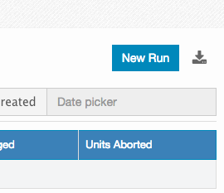
2. Next, download the sample data template and replace with your data in the spreadsheet. Then upload the spreadsheet having data by clicking choose file and then click Uplad spreadsheet.  
   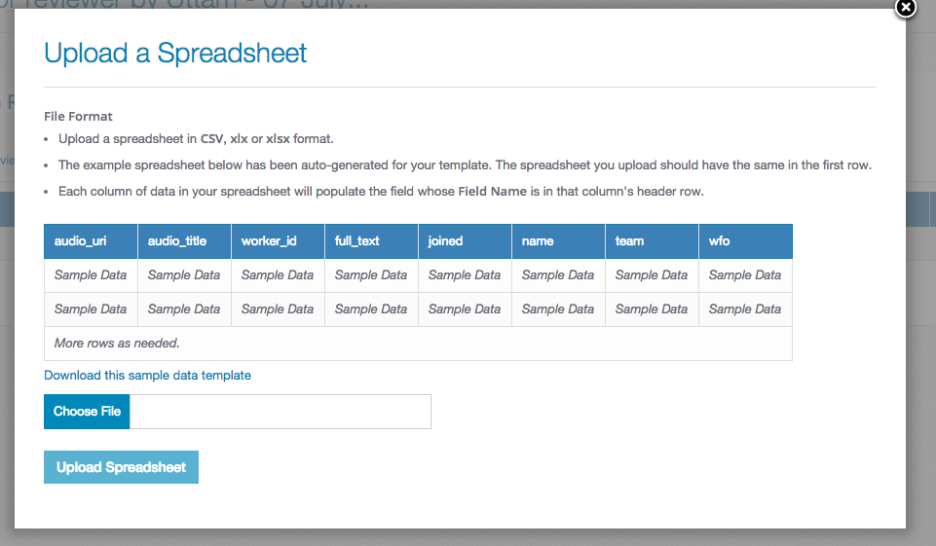
3. Thgen
4. The